CASE FILE 04
Frame Fitness
Product line: workout app memberships
Frame Fitness is a workout app built by two former college athletes. They want to replace their single $9.99 plan with three plans aimed at very different people.
Your job: Build a lineup of three versions, one for each segment below. For every version, choose its features and set its price. Your goal is the most total profit across all three.
THE MARKET: THREE SEGMENTS
Frame Fitness surveyed people in the Chicago area. The survey split them into three groups. Read the profiles, then give each segment a name.
SEGMENT A  20,000 potential customers | SEGMENT B  6,000 potential customers | SEGMENT C  5,000 potential customers
- Ages 25 to 50, has not worked out regularly in years  - Has 20 to 30 minutes on a weeknight  - Does not own any gym equipment  “Tell me exactly what to do for 20 minutes.” | - High school and college athletes  - Training for a specific sport in the off-season  - Already wears a smartwatch to track runs  “I want numbers. Am I getting faster or not?” | - Ages 30 to 55, owns a bike, rower, or weights at home  - Misses the energy of group classes  - Spent $1,000 or more on equipment  “I bought the rowing machine. Now give me a reason to use it.”
Our name for them: | Our name for them: | Our name for them:
PRODUCT BASICS
Base cost of every version | $1 per member per month, before any features are added
Price options | $3 $6 $10 $15 $20 $30 (each version must use one of these prices)
WARM-UP: READ THE DATA FIRST
1. Which segment has the most must-have features (60% or higher)? How many does it have?

2. What is the most expensive feature on the menu? Which segment, if any, says it is a must-have?

3. What is the lowest price at which fewer than half of Segment B would buy?

4. If Frame Fitness sold a version with a Fit of 100% to Segment A at $6, how many people would buy it?

SURVEY RESULTS: WHAT EACH SEGMENT REQUIRES
Question asked: “Which of these would a workout app membership need to have before you would buy it?”
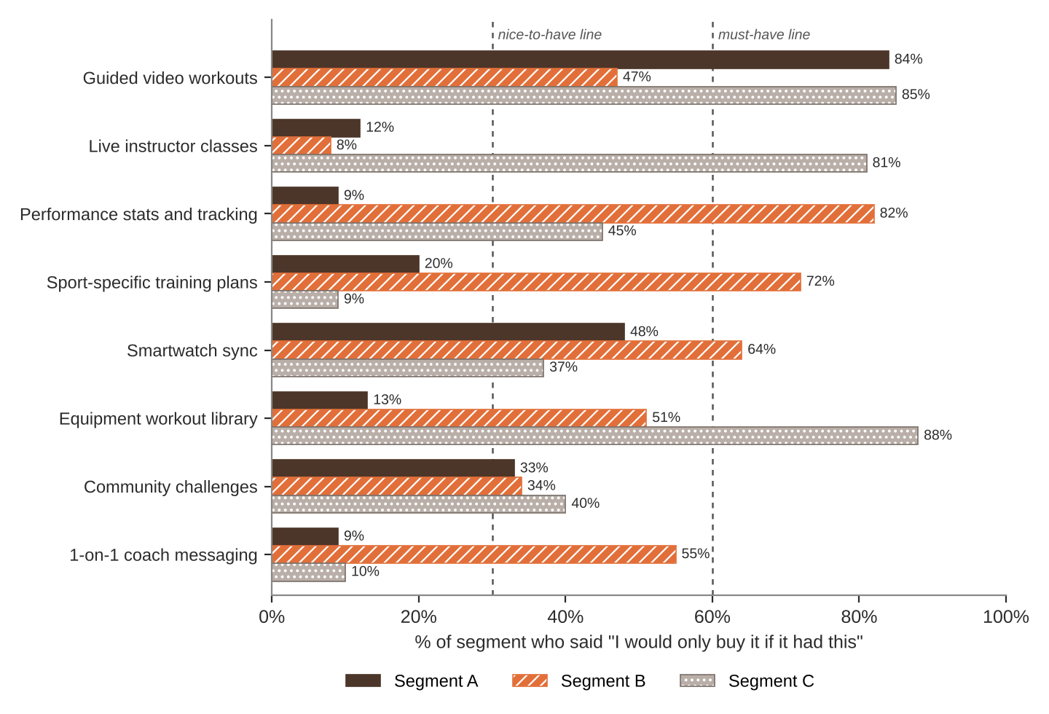
FEATURE MENU
Every feature you add raises your cost per member per month. Add a feature to any version you want.
Feature | What it is | Cost to add
Guided video workouts | Follow-along workouts from 10 to 45 minutes | $1
Live instructor classes | Real-time classes with a leaderboard | $4
Performance stats and tracking | Charts of speed, strength, and progress | $1.50
Sport-specific training plans | Plans for 12 sports, built by coaches | $2
Smartwatch sync | Pulls in heart rate and runs automatically | $0.50
Equipment workout library | Workouts for bikes, rowers, and weights | $1
Community challenges | Monthly team challenges and badges | $0.50
1-on-1 coach messaging | Text a real coach any time | $6
SURVEY RESULTS: WHAT EACH SEGMENT WILL PAY
Question asked: “If it had everything you need, would you buy it at this price?”
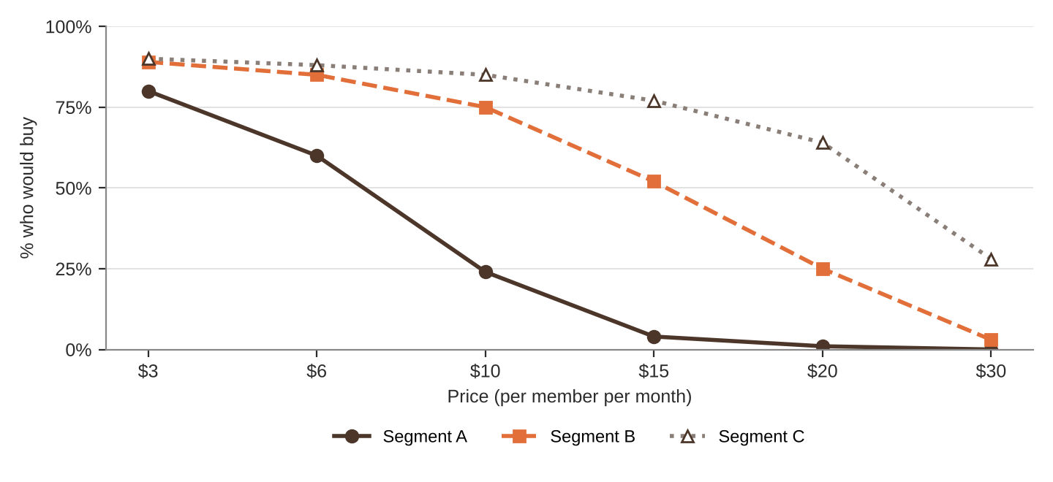
% of each segment who would buy at each price
Price | $3 | $6 | $10 | $15 | $20 | $30
Segment A | 80% | 60% | 24% | 4% | 1% | 0%
Segment B | 89% | 85% | 75% | 52% | 25% | 3%
Segment C | 90% | 88% | 85% | 77% | 64% | 28%
QUICK RULES
Must-have | A feature that 60% or more of a segment requires. Leave one out and that segment's buyers are cut in half. Leave two out and they're cut in half again.
Nice-to-have | A feature that 30% to 59% of a segment requires. Each one you include adds 5% to Fit.
Under 30% | That segment doesn't care. It adds cost and nothing else.
Fit | Start at 100%. Add 5% for each nice-to-have included. Then cut in half for each must-have left out.
Buyers | Segment size × % who would buy at your price × Fit. Round to a whole number.
Profit | Buyers × (Price − Unit cost). Unit cost = base cost + cost of every feature you added.

